Profiling results for a laptop:

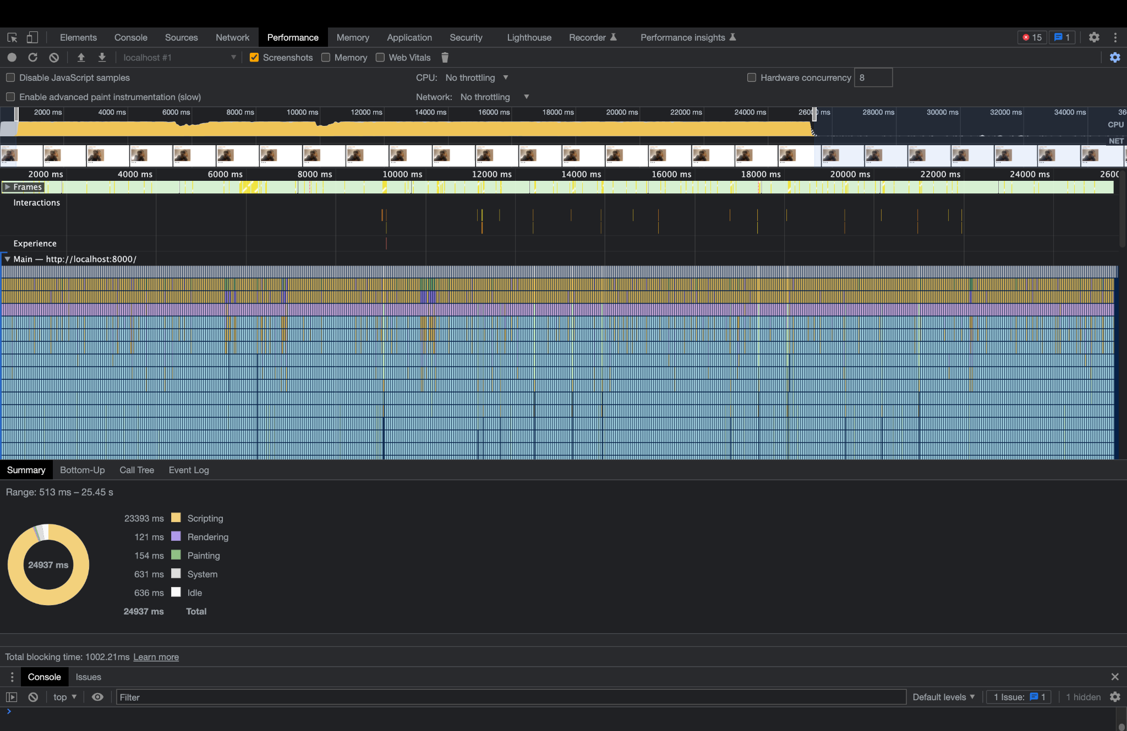

Figure 1

This image shows the profiling for the laptop based application. The profiling is done for 35 secs and in that time frame the scripting part takes 23.39 secs to complete. Painting and rendering of the detector points only take approx 100 - 150 ms each. The major scripting overhead comes from processing the tensors.

The snapshot below shows the memory heap consumption by various variables used in the script. 42% of the memory heap is occupied by Array Buffer data. The tensors are processed via the heap and reside in Array buffer data. There are 220 tensors stored in memory at the time of profiling.

If we observe the figures 3 and 4 carefully, we could see that animations, function calls and rendering (represented by orange and pink) are taking a relatively slighter slice of time. The pose estimation process (represented by blue) takes a slightly larger slice of time and the data i/o and internal tensor manipulation stuff (represented by green take the hugest slice of time). Based on this profiling the pose estimation pipeline is the one that is affecting the performance initially but if we observe carefully in figure 1, the bottlenecks only last until the script is loaded completely and the training process is complete (notice the decline in time taken after 26 secs) which means that this a one time thing and once the training is done, shouldn’t be a major issue.

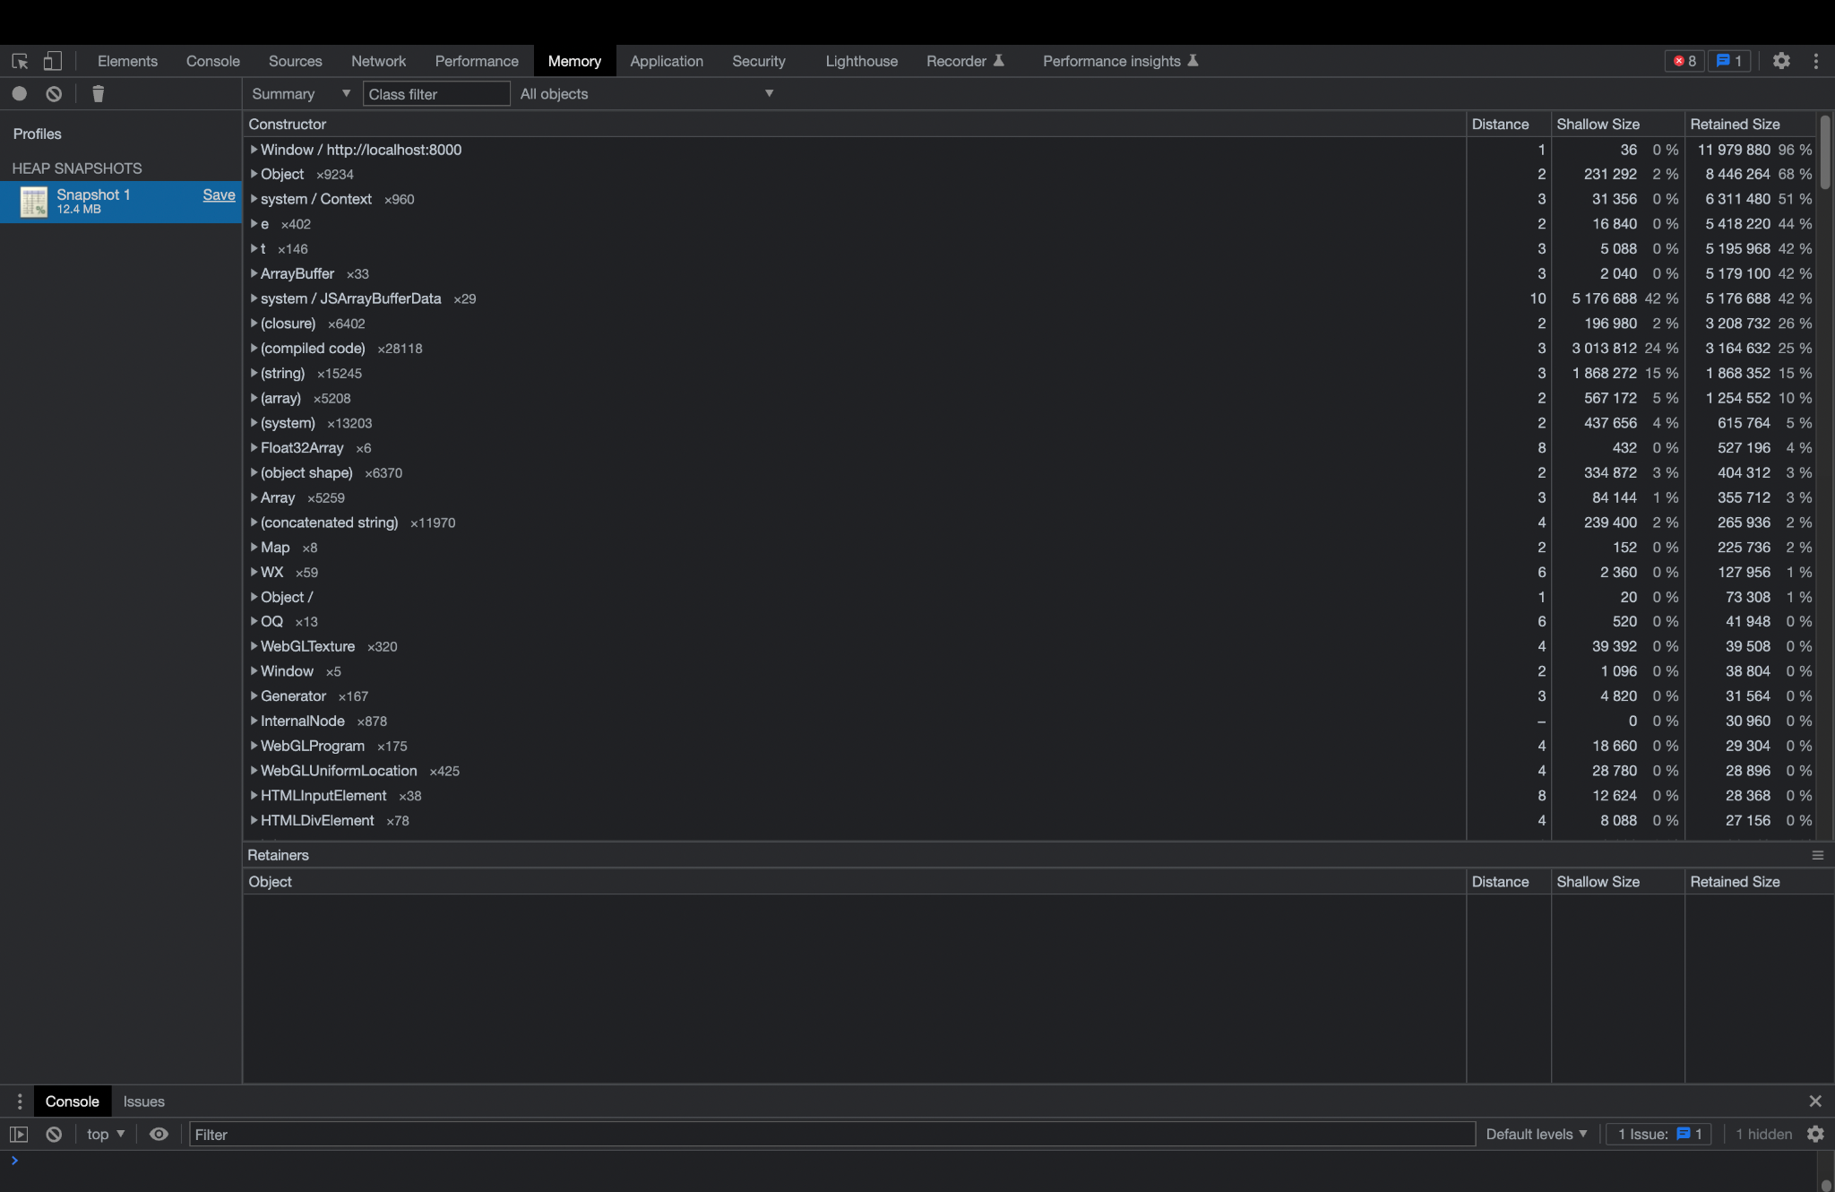

Figure 2

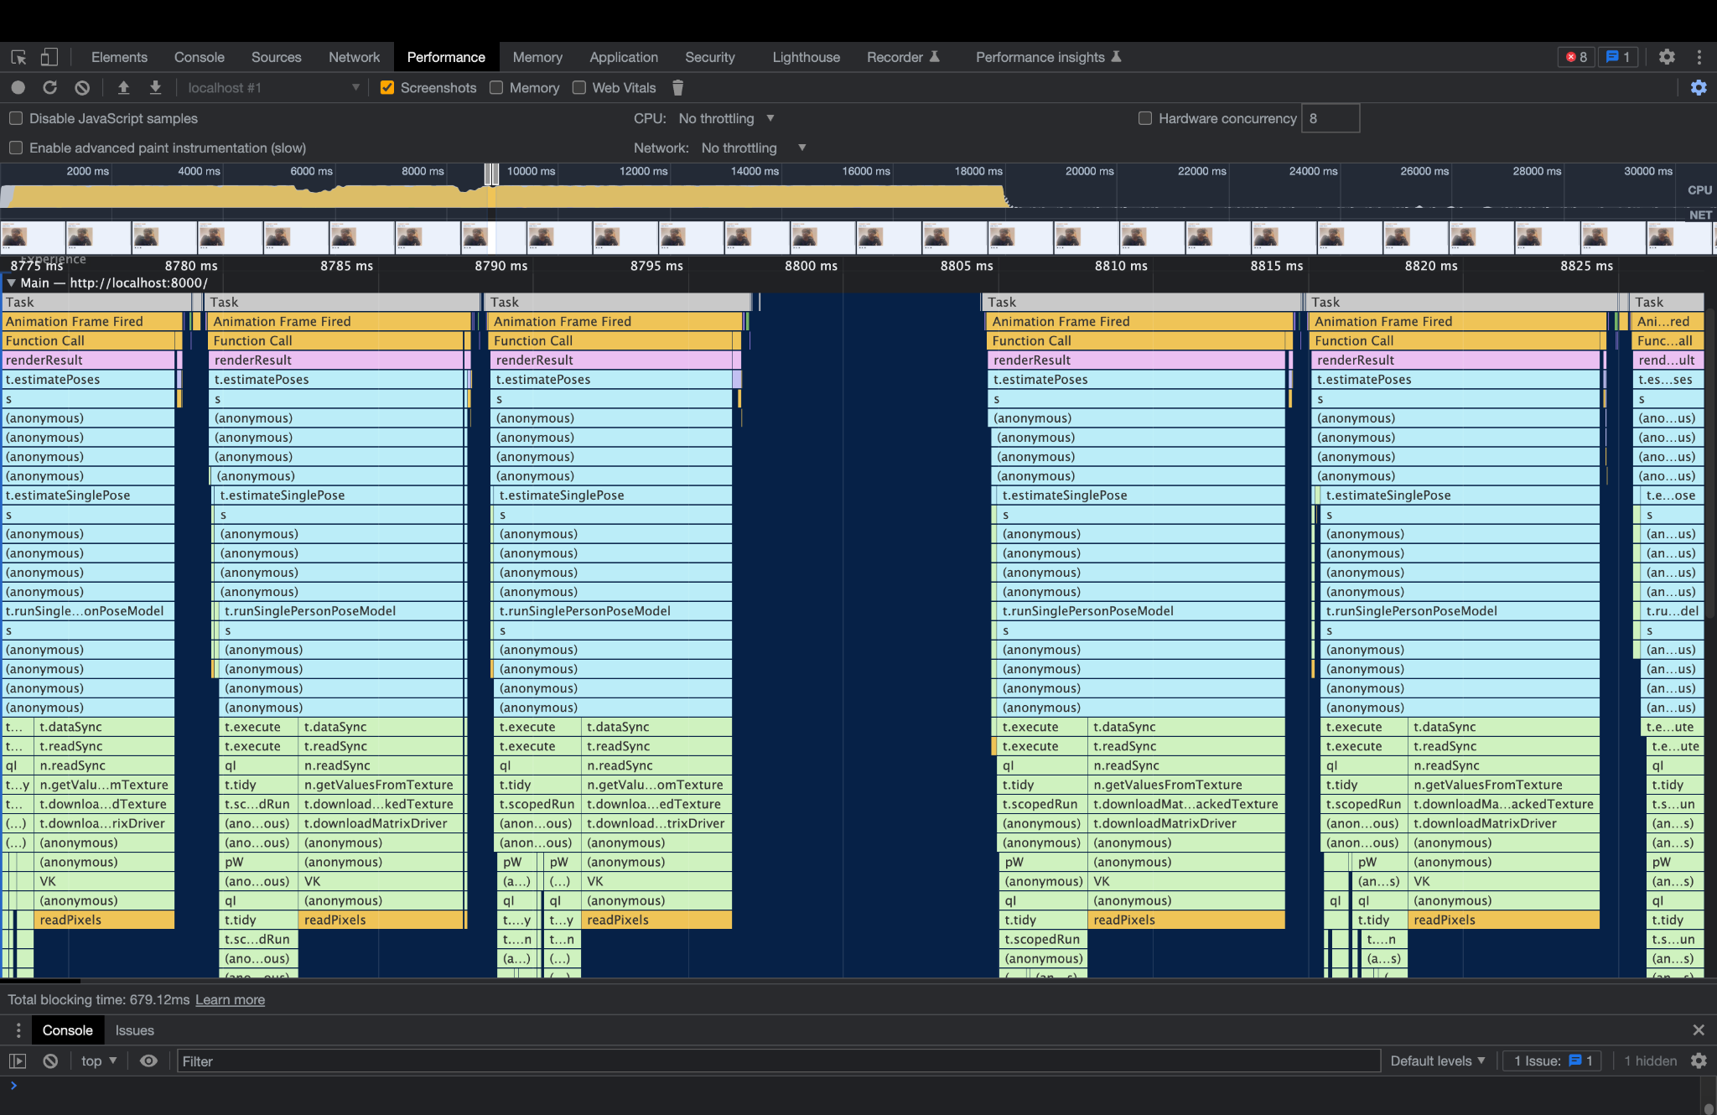

Figure 3

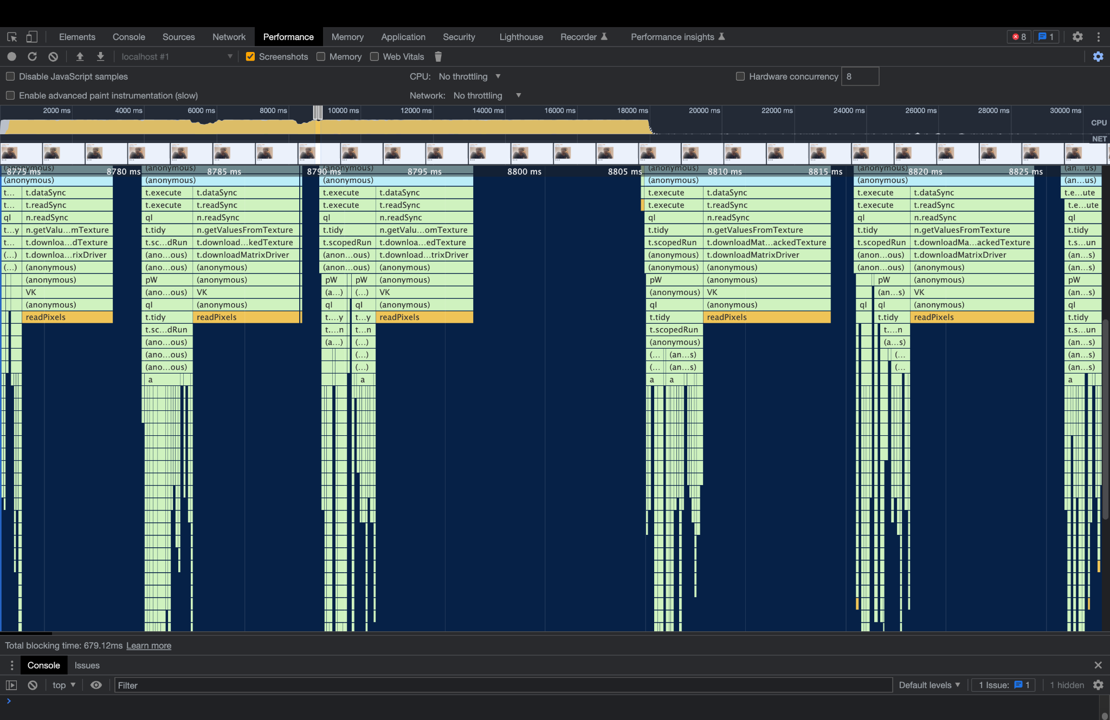

Figure 4

Profiling results for Mobile phone:

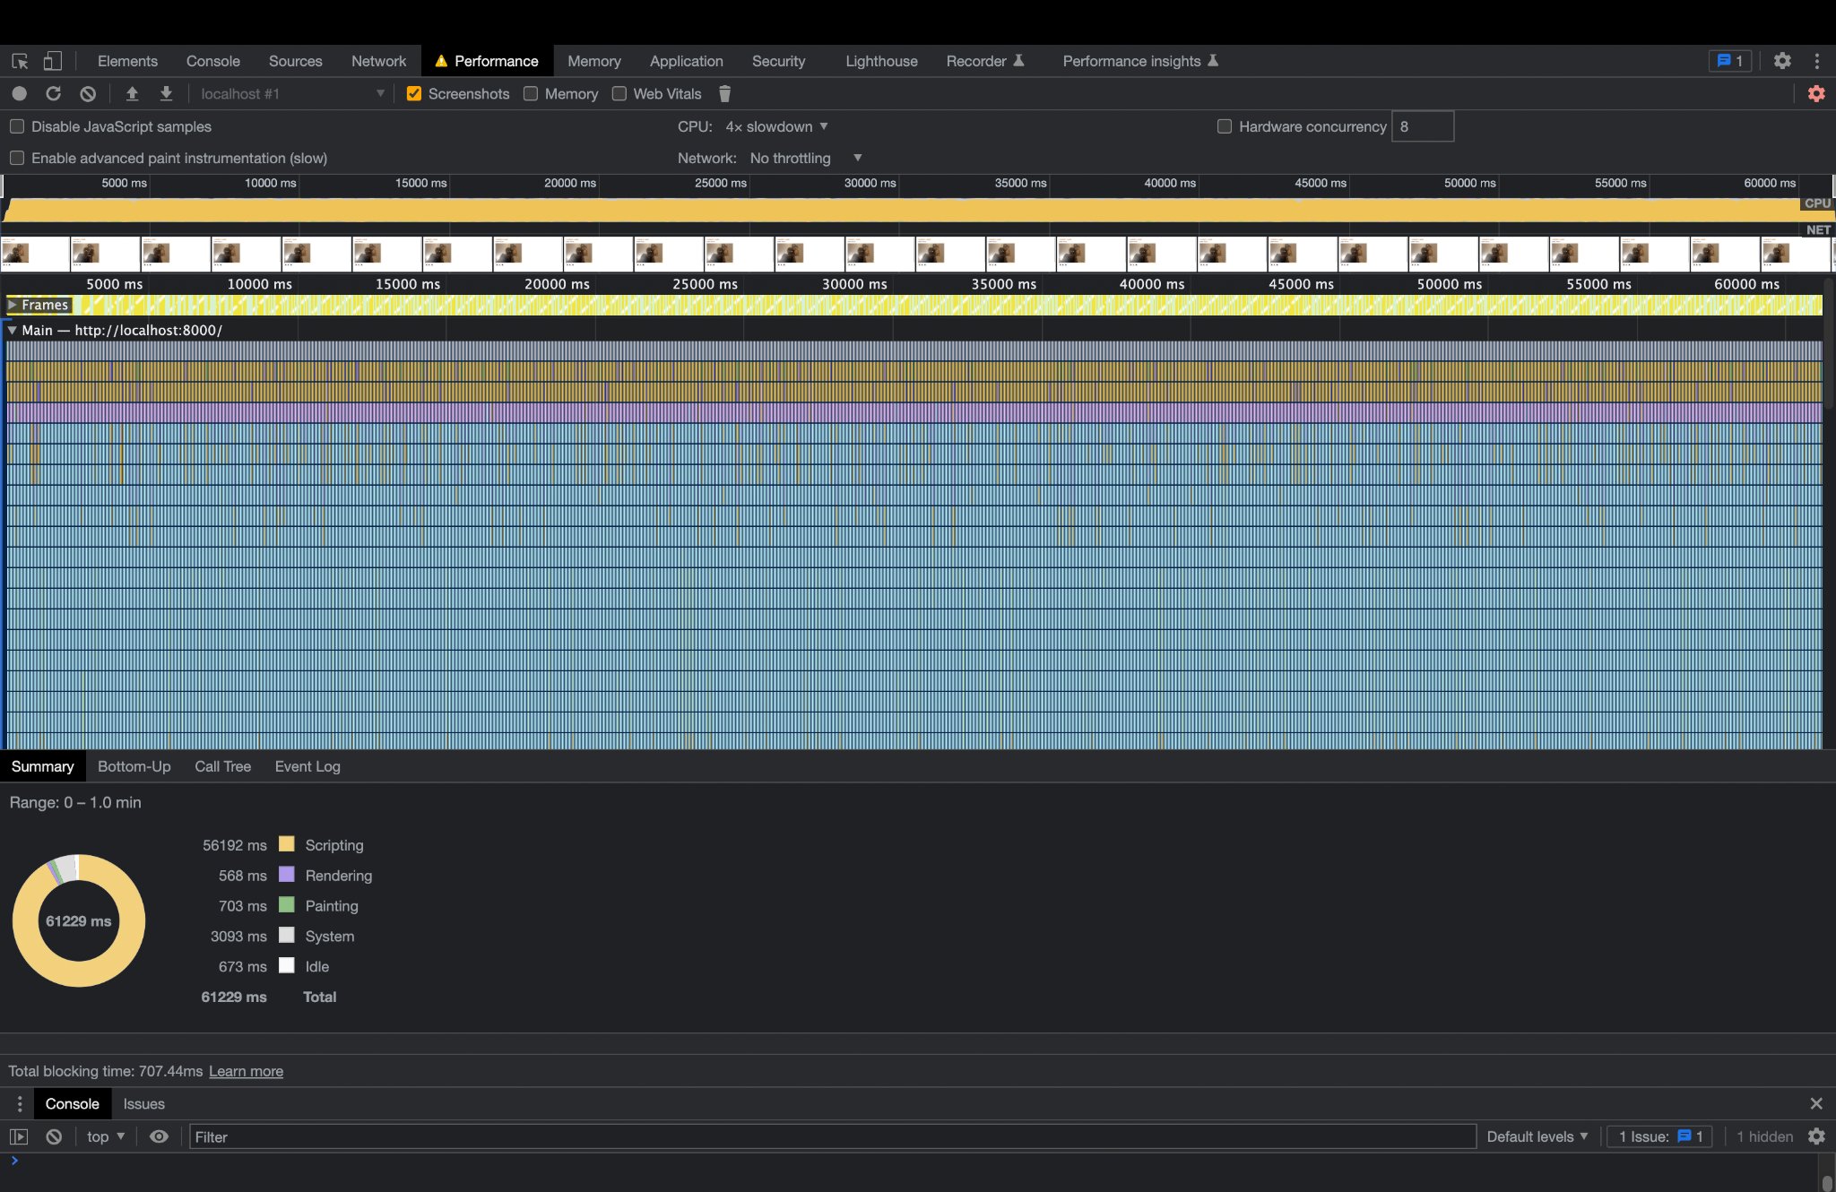

Figure 5

If we observe the above figure clearly, it is apparent that the script took a relatively longer time to load completely on a mobile device (profiled for 61 secs instead of 35 secs). Due to the limited memory footprint, there is a delay in loading and processing of data in the mobile processor.

Figure 6 shows that there were some critical issues with the loading of the website (took longer than usual). This clearly indicates that the memory availability in a Mobile phone is not sufficient enough which might cause bursts of decline in user experience while using the mobile version.

The memory profiling is very much the same as that of the laptop.

Now if we observe Figure 7 and 8, we can notice that the pose estimation (blue) is slightly longer in mobile version and data i/o and internal tensor manipulation stuff (green) has pretty much same duration as the laptop version.

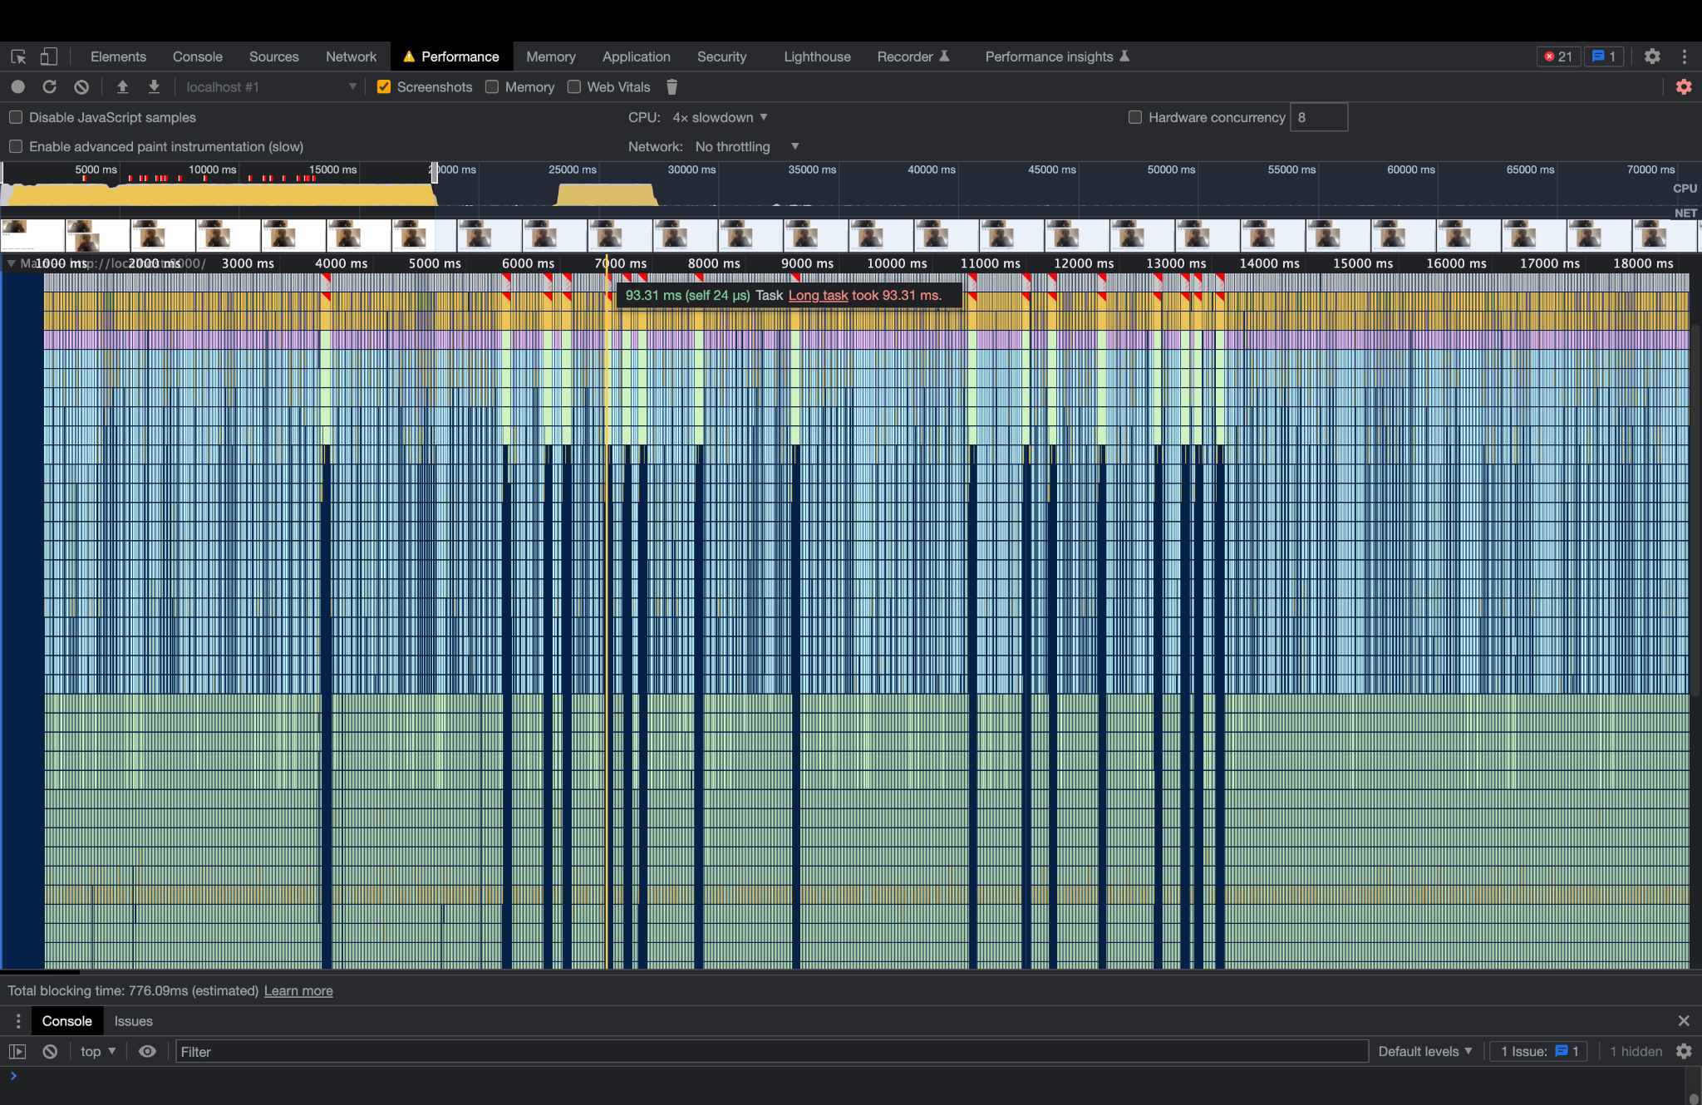

Figure 6

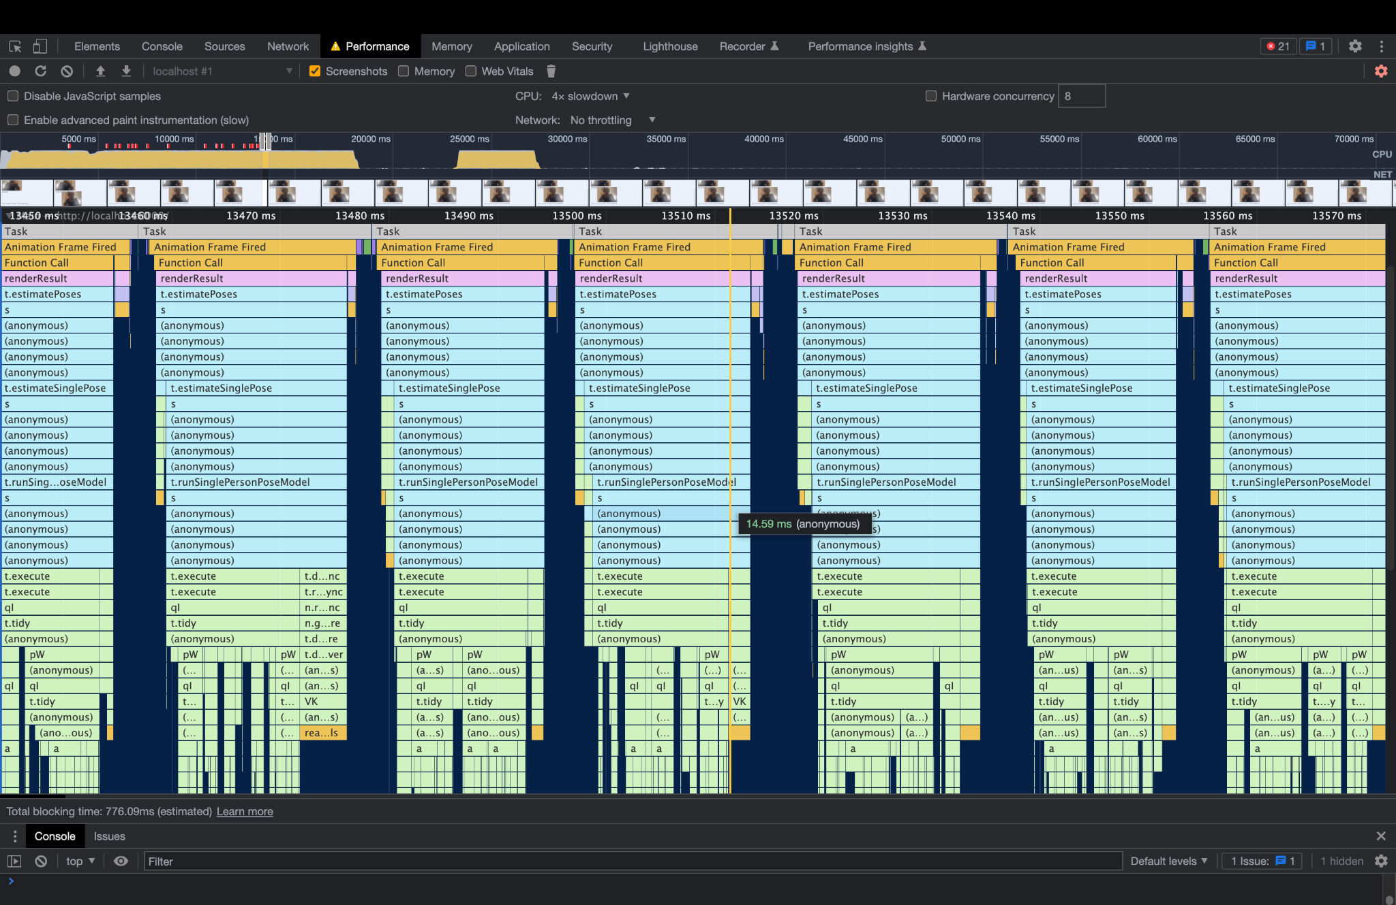

Figure 7

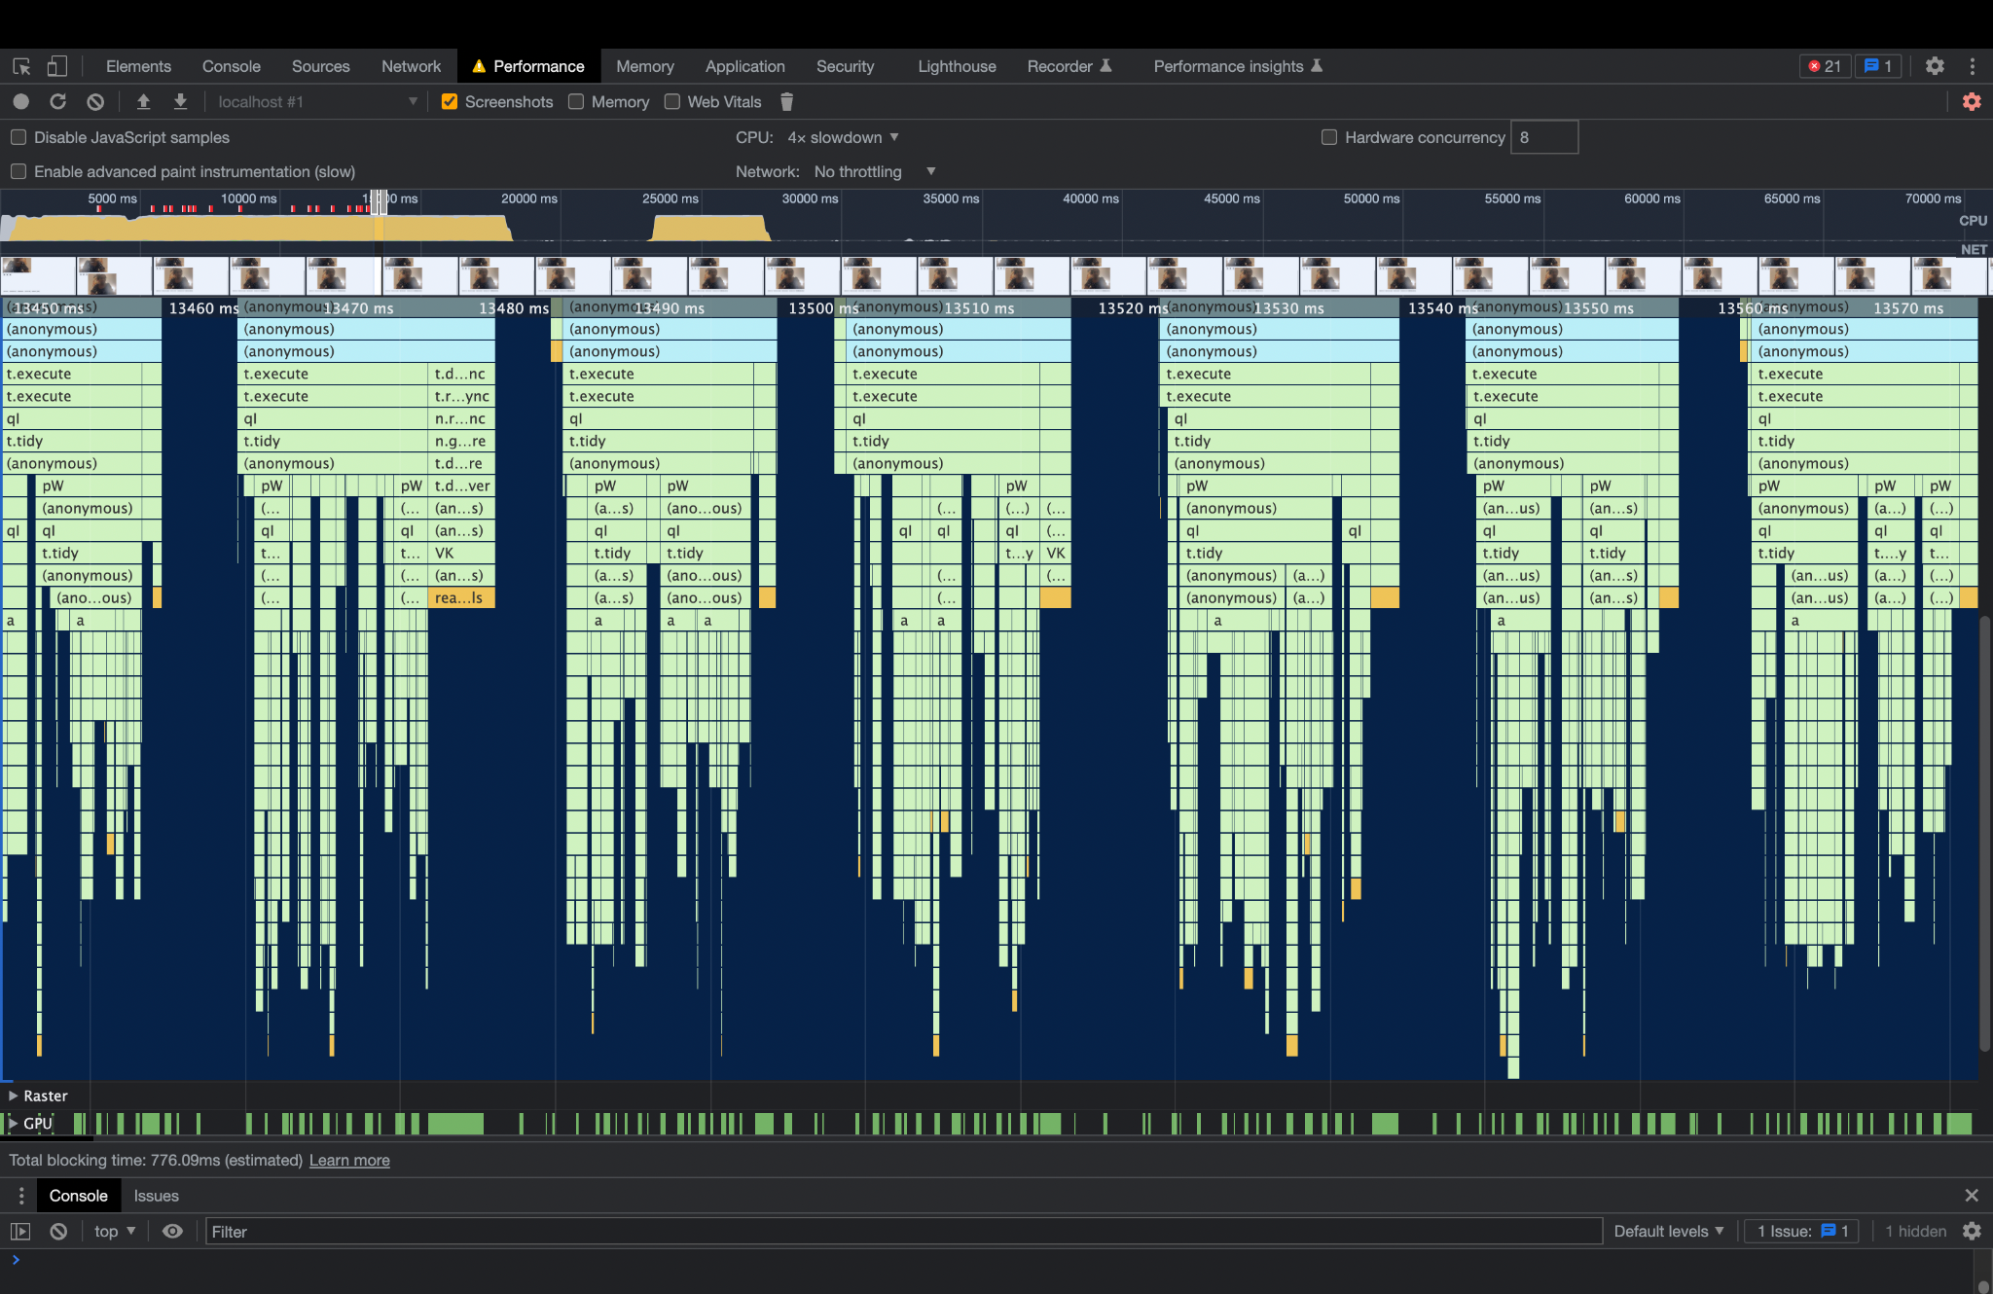

Figure 8

An observation worth mentioning is the duration of total blocking time in both the versions. The total blocking time is the number of sec/millisecs the main thread is blocked due to execution of tasks that essentially stop or interrupt the main thread. Now an interesting observation could be that the total blocking time in the laptop case is 1 ms and the total blocking time observed in the Mobile device is 670 - 700 ms. An interesting hypothesis would be that in the laptop due to the availability of larger chunks of memory, the parallel processing is rapid and multiple jobs compete with each other in a limited time frame for job execution. On the other hand in the mobile device, the parallel processing is low/absent and the wait time for threads is significantly low/null which causes this disparity.

Other profiling results:

We have also tried other tools like js-profiler for our approach. Although, it was not as comprehensive as the chrome developer tools, we found performance issues profile wise.

